**COMPSCI 115**

**Practice Exercises Module 5**

1. Write a program that reads a list of integers and displays them in the reverse order in which they were read.
2. Write a function that replaces each number in a list with its square value.

numbers = [12 ,34 ,56 ,2 ,5]

1. Write a program to add two elements 123 and 31 to the tuple at index 2 and 5

Numbers = (54, 67, 98, 45, 12, 10, 91, 54, 71, 45, 1, 12, 67, 12, 10 ,91, 50, 61). Print the updated tuple. Remove the elements 61 and 50 and then print the updated tuple

1. Write a function that returns the distinct elements of a list. Assume the function receives the list1= [16, 71, 26, 96, 51, 16, 31, 91, 26, 6, 71, 11, 6, 86, 76, 6, 11, 21, 91, 81]
2. Write a function called slice_list that receives a list and returns a new list that contains all elements except the first and last elements

lst=[2,4,6,7,8,9,23,45,67]

1. Write a program that reads an unspecified number of scores and determines how many scores are above or equal to the average and how many scores are below the average. Assume the input numbers are separated by one space in one line.

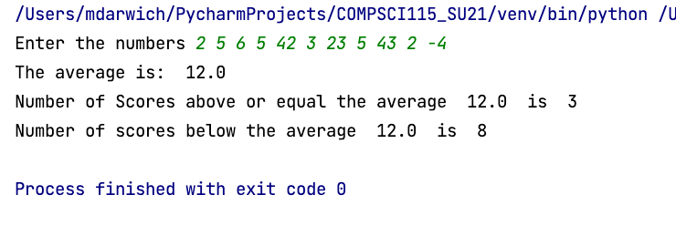

Your program should contain the following functions:

**def** getinput()

**def** computeScores(scores)

**def** main()

**if** __name__ == **'__main__'**:  
 main()

1. Write a program that reads a list of scores and then assigns grades based on the following scheme:

The grade is A if score is >= best−10.

The grade is B if score is >= best−20.

The grade is C if score is >= best−30

The grade is D if score is >= best−40.

The grade is F otherwise.

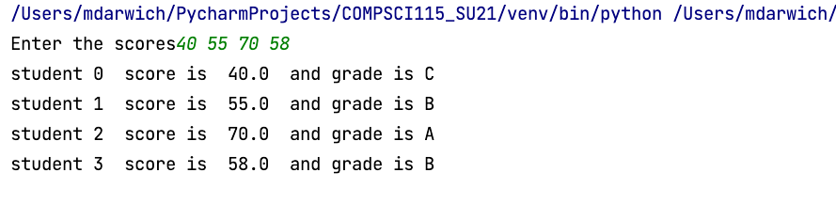

Your program should contain the following functions:

*# get the list of scores from the user and return it*

**def** getScores()

*# find the highest score and return it*

**def** bestScore(scores)

**def** main()

**if** __name__ == **'__main__'**:  
 main()

1. Write a program to compute the standard deviation of numbers. The formula to compute the standard deviation of n numbers.

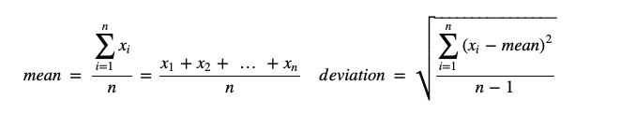

To compute the standard deviation with this formula, you have to store the individual numbers using a list so that they can be used after the mean is obtained.



Your program should contain the following functions:

*# get the numbers from the user*

**def** getNumbers()*# return the list numbers*

*# calculate the mean of the list and return it***def** mean_list(list_numbers):

*# caluclate the standard deviation and return it***def** deviation_list(list_numbers, mean)

*# Invoke getNumbers(), mean_list(), and deviations_list() and print the mean and deviation***def** main()

*# Invoke the main function main()*

**if** __name__ == **'__main__'**:  
 main()